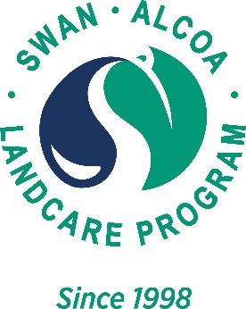
Swan Alcoa Landcare Program 2024
Declaration of Approval
From the landowner to the <insert applicant name>
Written approval is required to undertake a Swan Alcoa Landcare Project in 2024 on your property. This project is in conjunction with the <insert applicant name>. Please complete the form below.
Project Title: _______________________________________________________________________
Subproject Title(s): ______________________________________________________________________________________________________________________________________________________________________________________________________________________________________________________
Landholder:
I/we declare that I have been consulted about this project and certify that the necessary approvals have been obtained for it to proceed.
Signature: | Signature:
Name: | Name:
Date: | Date:

Applicant:
Signature:
Name:
Date:
Position:

